Southern Pigeon Club  Membership Form | 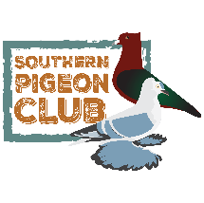

Contact Information
Name
Address
City, State, Zip
Phone
Email Address

Membership Type
Individual $20
Family $25
Youth $5

Family Members Names (If Family Membership)
Name:
Name:
Name:
Name:

List of Breeds You Raise

Total: $_______________ Payment Type: Cash Check#_________ Card

--------------------------------------------------------------------------------------------------------------------------------------------

Thank you for becoming a member of the Southern Pigeon Club!
Be sure to look us up on Facebook and check our website for upcoming events and more!
Please make check payable to: Southern Pigeon Club
Send forms to: 13550 Hwy 28 East, Deville LA 71328

www.southernpigeonclub.com southernpigeon@gmail.com Facebook.com/southernpigeonclub

